4.4.3.1 Class “BaseEntitty”

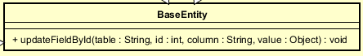

Attribute:

None

Operation:

|  |  |  |  |
| --- | --- | --- | --- |
| # | Name | Return type | Description (purpose) |
| 1 | updateFieldById | void | Update column any table in database with primary key id by value |

Method: None

State: None

4.4.3.2 Class “Bike”

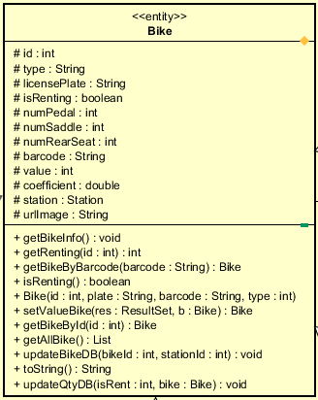

**Attribute**

|  |  |  |  |  |
| --- | --- | --- | --- | --- |
| # | Name | Data type | Default value | Description |
| 1 | numSaddle | int | NULL | Number saddle of the bike |
| 2 | numPedal | int | NULL | Number pedal of the bike |
| 3 | numRearSeat | Int | NULL | Number rear seat of the bike |
| 4 | licensePlate | String | NULL | Represent license plate of the bike |
| 5 | value | int | NULL | Represent value of the bike |
| 6 | barcode | String | NULL | Represent barcode of the bike |
| 7 | type | String | NULL | Represent type of the bike |
| 8 | station | Station | NULL | Represent bike in which station |
| 9 | Coefficient | double | NULL | The coefficient uses when calculate deposit |
| 10 | urlImage | String | NULL | The path to the bike image |
| 11 | isRenting | boolean | NULL | Check if the bike is being rented or not |
| 12 | Id | Int | NULL | The id of the bike in database |

**Operation**

|  |  |  |  |
| --- | --- | --- | --- |
| # | Name | Return type | Description (purpose) |
| 1 | getBikeInfo | void | Get bike information for display |
| 2 | getRenting | int | Check the bike with corresponding id is being rented or not |
| 3 | Bike | void | Constructor |
| 4 | getter | void | Get all attribute in acronym |
| 5 | setter | void | Set value for each attribute in acronym |
| 6 | getBikeByBarcode | Bike | Get a bike using its barcode |
| 7 | isRenting | Boolean | Check if a bike is currently being rented |
| 8 | setValueBikes | Bike | Set a bike info base on a result set |
| 9 | getBikeByID | Bike | Get a bike by using its id |
| 10 | getAllBike | List[bike] | Get all the bike in database |
| 11 | updateBikeDB | Void | Change the station of a bike in database |
| 12 | toString | String | Convert a bike object to string |
| 13 | updateQtyDB | Void | update station and bike when a bike is returned/rented |

Method: none

State:

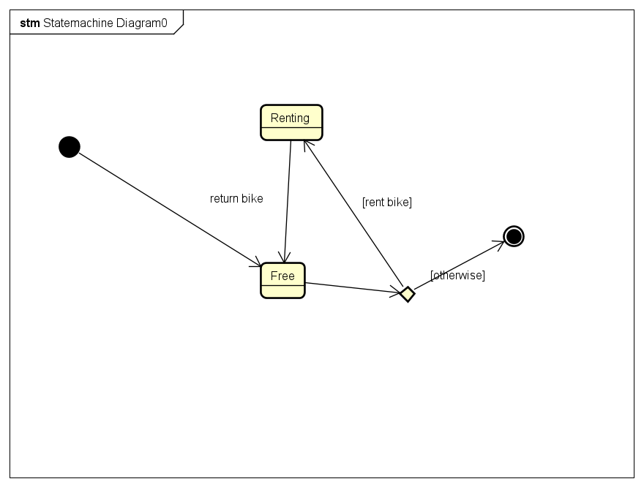

4.4.3.3 Class “Standard Bike”

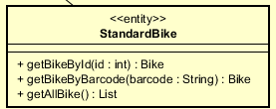

**Attribute**

**Operation:**

* **Inherit from bike entity and override**

|  |  |  |  |
| --- | --- | --- | --- |
| # | Name | Return type | Description (purpose) |
| 1 | getBikeById | Bike | Get a standard bike by its id |
| 2 | getBikeByBarcode | Bike | Get a standard bike by its barcode |
| 3 | getAllBike | List[Bike] | Get all standard bike |

**Method:** none

**State:** none

4.4.3.4 Class “Standard Electric Bike”

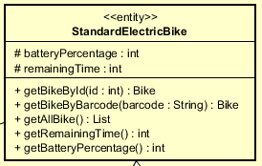

**Attribute**

|  |  |  |  |  |
| --- | --- | --- | --- | --- |
| # | Name | Data type | Default value | Description |
| 1 | batteryPercentage | int | NULL | The battery percentage of the electric bike |
| 2 | remaningTime | int | NULL | The remaining time of the electric bike |

**Operation:**

* **Inherit from bike entity and override**

|  |  |  |  |
| --- | --- | --- | --- |
| # | Name | Return type | Description (purpose) |
| 1 | getBikeById | Bike | Get a standard electric bike by its id |
| 2 | getBikeByBarcode | Bike | Get a standard electric bike by its barcode |
| 3 | getAllBike | List[Bike] | Get all standard electric bike |
| 4 | Getter/setter | Void | Get/set attribute in acronym |

**Method:** none

**State:** none

4.4.3.5 Class “Twin Bike”

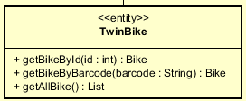

**Attribute**

**Operation:**

* **Inherit from bike entity and override**

|  |  |  |  |
| --- | --- | --- | --- |
| # | Name | Return type | Description (purpose) |
| 1 | getBikeById | Bike | Get a twin bike by its id |
| 2 | getBikeByBarcode | Bike | Get a twin bike by its barcode |
| 3 | getAllBike | List[Bike] | Get all twin bike |

**Method:** none

**State:** none

4.4.3.6 Class “Twin Electric Bike”

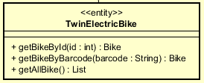

**Attribute**

**Operation:**

* **Inherit from standard electric bike entity and override**

|  |  |  |  |
| --- | --- | --- | --- |
| # | Name | Return type | Description (purpose) |
| 1 | getBikeById | Bike | Get a twin electric bike by its id |
| 2 | getBikeByBarcode | Bike | Get a twin electric bike by its barcode |
| 3 | getAllBike | List[Bike] | Get all twin electric bike |

**Method:** none

**State:** none

4.4.3.7 Class “EcoBikeRental”

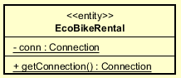

***Attribute***

|  |  |  |  |  |
| --- | --- | --- | --- | --- |
| # | Name | Data type | Default value | Description |
| 1 | Conn | Connection | NULL | Connection to the remote database |

***Operation***

|  |  |  |  |
| --- | --- | --- | --- |
| # | Name | Return type | Description (purpose) |
| 1 | getConnetion | Connection | Connect to the remote database |

***Method:*** None

***State:*** None

4.4.3.8 Class “Invoice”

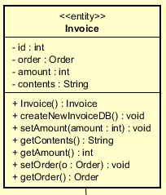

***Attribute***

|  |  |  |  |  |
| --- | --- | --- | --- | --- |
| # | Name | Data type | Default value | Description |
| 1 | Id | Int | NULL | The id of the invoice |
| 2 | order | Order | NULL | The order that was used for this invoice |
| 3 | Amount | Int | NULL | The amount the user has to pay/is refunded to. |
| 4 | content | String | NULL | The details of the invoice |

***Operation***

|  |  |  |  |
| --- | --- | --- | --- |
| # | Name | Return type | Description (purpose) |
| 1 | Invoice |  | Constructor |
| 2 | newInvoiceDB | void | Save the invoice to the database, after successful transaction |
| 3 | Getter/setter | void | Get/set attribute in acronym |

***Method:*** None

***State:*** None

4.4.3.9 Class “Order”

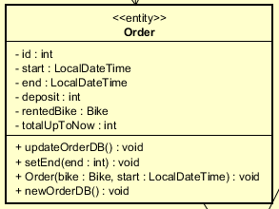

|  |  |  |  |  |
| --- | --- | --- | --- | --- |
| # | Name | Data type | Default value | Description |
| 1 | Id | Int | NULL | The id of the order |
| 2 | start | LocalDateTime | NULL | The time when user starts renting bike |
| 3 | End | LocalDateTime | NULL | The time when user returns bike |
| 4 | Deposit | Int | NULL | The amount of deposit when rent bike |
| 5 | rentedBike | Bike | NULL | The bike which is being rented |
| 6 | totalUpToNow | Int | NULL | Total renting amount (not include deposit) |

***Operation***

|  |  |  |  |
| --- | --- | --- | --- |
| # | Name | Return type | Description (purpose) |
| 1 | Order |  | Constructor |
| 2 | newOrderDB | void | Insert new order to database, after renting bike successfully |
| 3 | updateOrderDB | void | Update the order in the database, after returning bike successfully |
| 4 | Getter/setter | void | Get/set attribute in acronym |

***Method:*** None

***State:*** None

4.4.3.10 Class “Station”

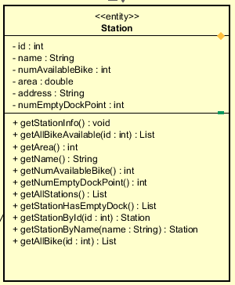

|  |  |  |  |  |
| --- | --- | --- | --- | --- |
| # | Name | Data type | Default value | Description |
| 1 | Id | Int | NULL | The id of the station |
| 2 | name | String | NULL | The name of the station |
| 3 | numAvailableBike | Int | NULL | Number of available bike in the station |
| 4 | Area | Double | NULL | Area of the station |
| 5 | Address | String | NULL | Address of the station |
| 6 | numEmptyDockPoint | Int | NULL | Number of empty dock point in station |

***Operation***

|  |  |  |  |
| --- | --- | --- | --- |
| # | Name | Return type | Description (purpose) |
| 1 | Station |  | Constructor |
| 2 | getAllBikeAvaiable | List[Bike] | Get all bike in a station with given station id, and the bike is currently not being rented |
| 3 | getAllStation | List[Station] | Get all the station in database |
| 4 | Getter/setter | void | Get/set attribute in acronym |
| 5 | getStationById | Station | Get a station with its id |
| 6 | getStationByName | Station | Get a station by its name |
| 7 | getAllBike | List[Bike] | Get all bike in a station with given station id |
| 8 | getStationHasEmptyDock | List[Station] | Get all stations which have empty dock for returning bike |

***Method:*** None

***State:*** None

4.4.3.11 Class “Card”

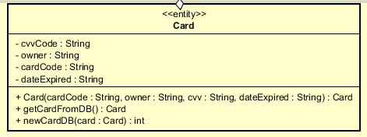

***Attribute***

|  |  |  |  |  |
| --- | --- | --- | --- | --- |
| # | Name | Data type | Default value | Description |
| 1 | owner | String | NULL | Name of the owner of the credit card |
| 2 | cardCode | String | NULL | code of the credit card |
| 3 | cvvCode | String | NULL | Security code of the credit card |
| 4 | dateExpired | String | NULL | The expiration date of the card, in form MMYY |

***Operation***

|  |  |  |  |
| --- | --- | --- | --- |
| # | Name | Return type | Description (purpose) |
| 1 | Card |  | Constructor |
| 2 | newCardDB | int | Save the card in the database if this is a new card. Get the id of the corresponding card in database. |
| 3 | getCardFromDB | Card | Get the card from database |
| 4 | Getter/setter | void | Get/set attribute in acronym |

***Method:*** None

***State:*** None

4.4.3.12 Class “TransactionInfo”

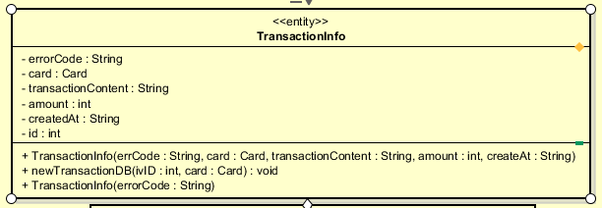

***Attribute***

|  |  |  |  |  |
| --- | --- | --- | --- | --- |
| # | Name | Data type | Default value | Description |
| 1 | card | Card | NULL | Represent the card used for payment |
| 2 | amount | int | NULL | Represent total amount of the transaction |
| 3 | TransactionContent | String | NULL | Represent content of transaction |
| 4 | createdAt | String | NULL | The time when the transaction was created |
| 5 | Id | Int | NULL | The id of the transaction |
| 6 | errorCode | String | NULL | The error code represents the state of the transaction |

***Operation***

|  |  |  |  |
| --- | --- | --- | --- |
| # | Name | Return type | Description (purpose) |
| 1 | TransactionInfo |  | Constructor |
| 2 | newTransactionDB | void | Save the successful transaction to database, and the card used for the transaction |
| 3 | Getter/setter | void | Get/set attribute in acronym |

***Method:*** None

***State:*** None